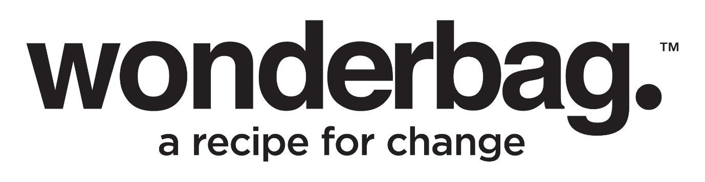

Press Release
For Immediate Release

Wonderbag's 'Going Home' Campaign :
A Black Friday Tale of Purpose, Innovation, and Sustainable Impact

While many retailers will report on the success of this year’s Black Friday sales, the South African business landscape also witnessed a distinctive approach to marketing which transcended the realm of mass consumerism. Wonderbag, a proudly African business, strategically carved its path with the 'Going Home' campaign within November by offering a unique perspective on how businesses can make a meaningful impact.

Wonderbag's 'Going Home' campaign is a groundbreaking marketing initiative redefining the narrative of Black Friday. Unlike traditional consumer-centric approaches, this campaign centres around purpose-driven innovation, emphasising sustainable impact and community welfare. Spearheaded by Wonderbag CEO and Founder Sarah Collins, the campaign unfolds a narrative through the lens of individuals like Qaqamba Ntshinka, a typical South African going home to her family in the Eastern Cape for the holiday season.

By positioning the Wonderbag as an integral component of the homecoming experience, this initiative not only addresses practical household needs but also actively contributes to the broader goals of environmental friendliness, low-cost accessibility, and positive community change. The 'Going Home' campaign stands as a testament to Wonderbag's commitment to a new era of consumer engagement that transcends transactional exchanges to embody a purposeful and sustainable business ethos.

“What excites me about our fresh approach in the build up to the festive season is how we are navigating our way through the cluttered retail space to really connect with South Africans and their real time needs and experiences. We are actively avoiding contributing to mass consumerism. Instead, we are championing low-cost initiatives that not only benefit all South Africans but also contribute to environmental sustainability,” explains Collins.

The Wonderbag, a cloth, heat-retention slow cooker, is a testament to this commitment, enabling efficient cooking without the need for excessive energy consumption. The Recipe for Change, a Wonderbag initiative spearheaded by Collins, takes Wonderbag's mission a step further. This ambitious project aims to integrate Wonderbags into the homes and kitchens of those who would benefit the most, while tracking the usage and carbon offsetting capabilities of this simple yet powerful bag. Under the Recipe for Change concept, Wonderbags are made accessible to vulnerable populations at an affordable price of R90, in stark contrast to the regular retail price of R450.

Collins states, "Recipe for Change is not just a project; it's a commitment to climate, community, and change - the 3C's that drive Wonderbag's vision. We believe in creating positive impacts within communities by providing a practical solution that aligns with the UN's 17 Sustainability Goals."

The Wonderbags distributed through the Recipe for Change project are subsidised using Carbon Credits, ensuring their accessibility to households that need them the most. Collaborating with like-minded organizations, Wonderbag issues high-quality carbon credits certified by Verra. This strategic partnership not only funds the manufacturing and distribution of Wonderbags but also amplifies the company's reach, catalysing positive change across Africa.

In stark contrast to the Black Friday noise of fast fashion and irresponsible consumerism, Wonderbag presents a model of purpose-driven innovation looking to actively contribute towards sustainable practices and community well-being. The November launched campaign of Wonderbag centres around a real-life, documentary-style exploration of 'Going Home with Wonderbag,' showcasing the transformative power of this simple yet impactful cooking tool.

#goinghomewithwonderbag
#wonderbag
#recipeforchange

Connect with Wonderbag on:
Instagram: @TheWonderbag
Facebook: Facebook.com/TheWonderbag
Twitter: @WonderbagO
LinkedIn: Wonderbag
Website: www.wonderbagworld.com and Recipe for Change www.recipeforchange.co.za

ENDS

WORDS  PICTURES  DATE | :  :  : | 554  Images of Wonderbag, Sarah Collins and Qaqamba Ntshinka  November 2023

Notes to Editor:

About Wonderbag: The Wonderbag is a revolutionary, non-electric, heat retention cooker that allows food that has been brought to the boil by conventional methods, to continue cooking for up to 8 hours, without using an additional energy source. Not only is the Wonderbag a revolution in the kitchen, but it is also a recipe for social change. The world has embraced the Wonderbag because of its environmental attributes and particularly its social contributions – that includes it being coined by carbon and climate change experts as, “the only scalable carbon offset project in existence”.

Wonderbag is one of the fastest growing registered carbon projects in Africa and is changing the model of aid as we know it. In South Africa, Natural Balance has registered the Wonderbag project as a carbon offset project, unique to any other carbon offset project in South Africa. The Wonderbag offset has significant sustainable development benefits.

Wonderbag was founded in South Africa in 2008 by local entrepreneur and social activist, Sarah Collins, and the product was born out of a practical desire to continue cooking during a bout of Eskom load shedding. Since opening its doors, the company has grown exponentially, and this local product has crossed over borders into various overseas markets.

For more information or visuals, please contact Janna Strang on
janna@rainmakermarketing.co.za / 082 551 3865 or email tasha@rainmakermarketing.co.za

